**LAB TASKS**

*24K-0706*

***PSEUDOCODE***

1. **Find if the number is multiple of 5.**
2. START
3. INPUT number.
4. Divide given number by 5.
5. IFremainder is 0, THEN
6. Print (“The number is multiple of 5”)
7. ELSE
8. Print (“Not a multiple of 5.)
9. END
10. **Check if a character is uppercase or lowercase.**
11. Start
12. Input character.
13. IF character is >A or <Z, THEN
14. Print (“The character is upper case.”)
15. IF character is >a or <z, THEN
16. Print (“The character is lowercase”).
17. END
18. **Create a small calculator which only does ‘+’ or ‘*‘Operations. (Hint: Take three variable inputs with one being used for the operator).**
19. Start
20. Input a
21. Input b
22. If clicked “**+**” THEN,
23. Print (“a **+** b”)
24. IF clicked “**\***” THEN,
25. Print (“a **\*** b”)
26. END
27. **Check whether a number is positive, negative or zero.**
28. Start
29. Input number.
30. IF number is >0 THEN,
31. Print (“The number is positive”)
32. IF Number is <0 THEN,
33. Print (“The number is negative”)
34. IF number is =0 THEN,
35. Print (“The number is zero.”)
36. END
37. **Determine if a person is a teenager (between 13 and 19 years old).**
38. Start
39. Input age.
40. IF age is >13 or <19 THEN,
41. Print (“You are a teenager”)
42. ELSE
43. Print (“You are not a teenager”)
44. END

***ALGORITHMS***

1. **Implement an algorithm to determine if a given year is a leap year. A leap year is divisible by 4, but not divisible by 100, except if it is also divisible by 400.**
2. Ask user for any year number.
3. Check if the year number is divisible by 4.
4. Check if the year number is divisible by 100.
5. If 2nd statement is true and 3rd statement is false, then year is a leap year.
6. If both are false OR 2nd is false and 3rd is true, THEN the year is not a leap year.
7. **Implement an algorithm to count the number of occurrences of each character in a given string.**
8. Ask user to input a string.
9. Ask user which character’s occurrences should be counted.
10. Check for that letter’s occurrence in that string.
11. Count the number of occurrence of that given letter in that string.
12. Display the number of occurrence.
13. **Write an algorithm to calculate x raised to the power y (i.e., x^y ) without using built-in power functions.**
14. Ask user to input base(x).
15. Ask user to input power(y).
16. Multiply number (x), (y) times with number (x).
17. Display result.
18. **Calculate the area of circle given its radius.**
19. Ask user for radius of the circle.
20. Calculate the area of the circle by multiplying radius*radius*3.14.
21. Display area of circle.
22. ***Calculate median of 3 numbers.***
23. Ask user to input three numbers.
24. Check for the middle one.
25. Display the median of the numbers.

**GitHub Introduction**

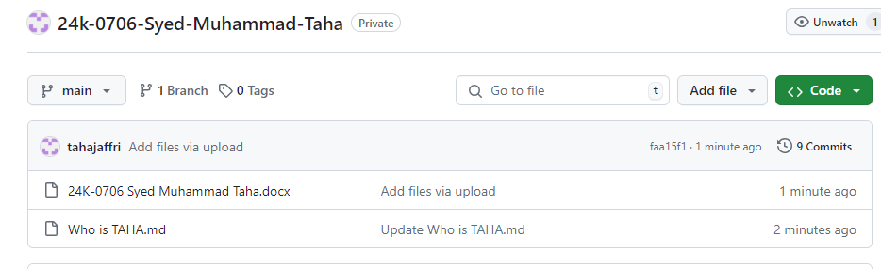



**Flow Chart**

1. **You are working in an e-commerce company and need to design a flowchart for processing an online order. The flowchart should include process modules for each step involved in handling an order and decision structures to handle stock availability and payment verification.**

END

END

Don’t process order. Wait for payment

Start processing of order

False

True

Verify if payment

is done.

Print “Please proceed to payment”

Print “available”

Yes

Order

placed

Print “Not available”

No

Start